Instructions for Scarp_offset_v4g.m

Written by Chris DuRoss (cduross@usgs.gov), version v4g; December 6, 2016. Please let me know if you have any questions, comments, or improvements.

The Matlab script Scarp_offset_v4g.m loads a single scarp profile and uses multiple measurement iterations to determine a preferred, mean, or midpoint offset value and minimum–maximum range. Individual-measurement and summary values, Matlab variables, and a figure of the preferred offset are written to the directory.

Notes
- Before you begin, copy the Scarp_offset_v4g.m script as well as the subroutine “slopeangle_f.m” to the folder containing the scarp profile data.
- Most commands use 1 = yes and 0 = no.
- If you screw up a measurement, just cycle through the dialog boxes until you have an option to “include results?” – input 0 (no). Then continue re-running the measurement…see additional explanation below.

Input files
Input files should consist of text files with two columns in the same units: (1) horizontal distance and (2) vertical distance. Absolute or relative distances are fine.

If you have any text at the top of the text file (e.g., notes on profile location), comment it out by placing a “%” before each line.

File types allowed are “.txt” (e.g., tab delimited text file from Excel) and “.dat” (Matlab data file).

Example input file:
%Profile X, measured at site Y
%Horizontal distance (m); vertical distance (m)
0 2087.79
0.99 2087.79
1.99 2087.78
3.00 2087.77
…

Measuring Scarp Offset:

1. Run Scarp_offset_v4g in Matlab. Select the file name for the profile you wish to load and evaluate.
2. Subset of profile data? Choose whether to select a subset of the profile data. This is helpful if you have a long profile and want to zoom into the scarp.
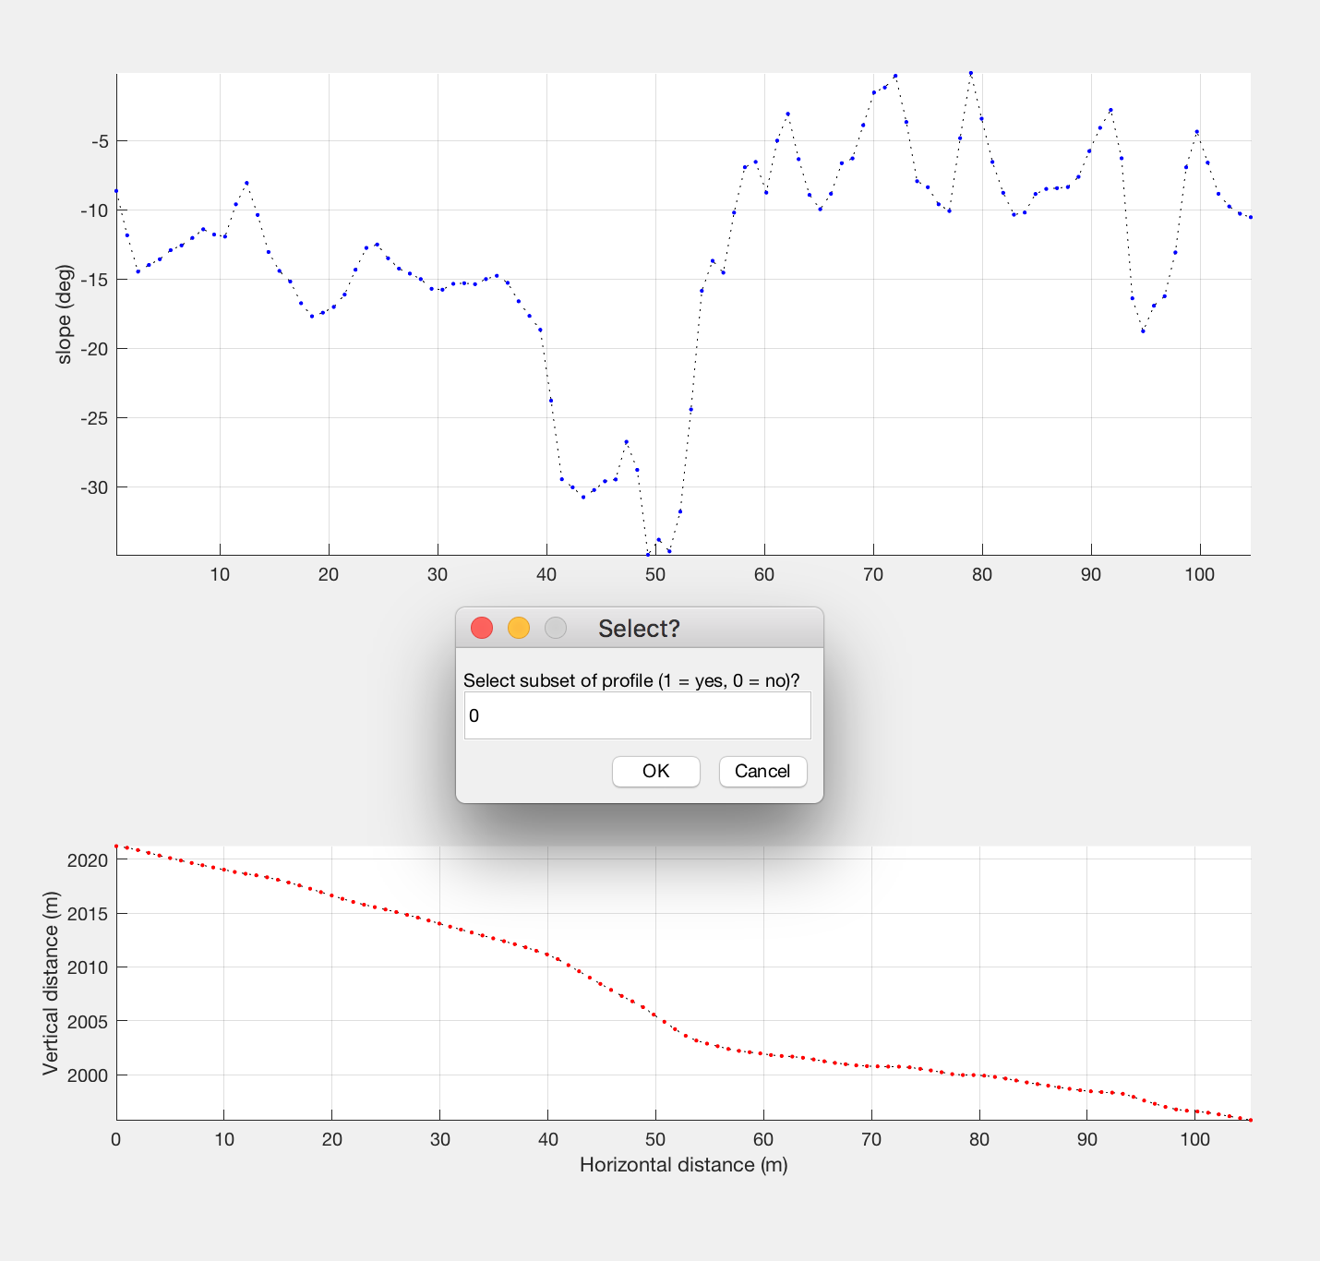
Selecting yes (1) will re-plot the profile inside the two distance values selected. You will be asked to click twice to define the horizontal points used for replotting.

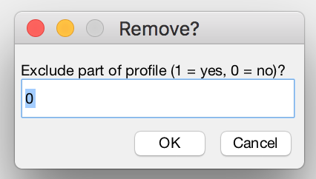
3. Exclude data? Choose whether to exclude part of the profile.

This step is geared toward non-bare-earth (e.g., structure from motion) elevation data or cases where you have a modified surface within the upper or lower surfaces, and allows you to remove these points from further consideration. For example, above-ground points related to a bush could be excluded so that they do not influence the surface-slope measurement. If no (0), move to step 4.

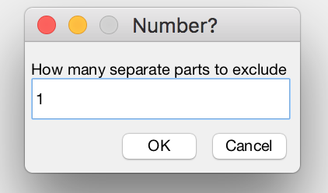
If yes (1) is selected, tell the program how many features you want to remove. In the example below, I want to remove one group of points.

For each feature, you will then be asked to click twice to remove the points.
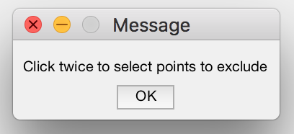

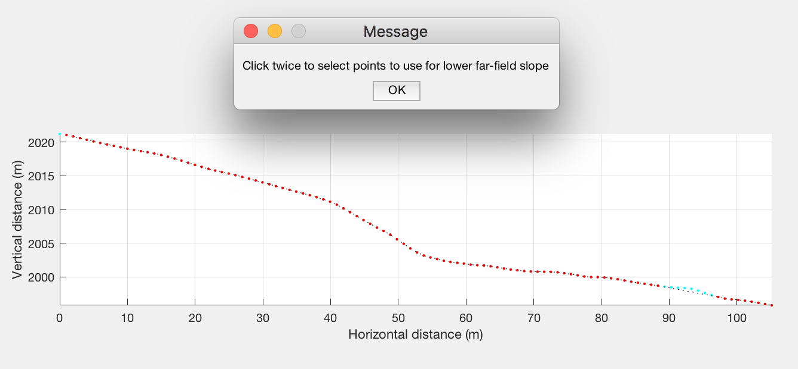
The points selected will plot in cyan…they will not be used for slope measurements (for example, if you selected lower far-field points between 70 and 105 m, these points would be excluded.

4. Select points for surface-slope determinations. In the lower panel (topographic profile), select points to be used to define the lower and upper far-field slopes and scarp slope. Points selected will be used to determine surface slopes and ultimately the offset across the scarp. To select points, line up the crosshairs (which show up once you click “OK”) in the lower panel, paying attention to the horizontal distance values. It is helpful to use the upper panel (slope vs. distance plot) to guide your point selection (e.g., by looking for points that yield the most consistent surface slope). You may need to adjust the figure size so that the slope and profile subplots are depicted at the same horizontal scale.
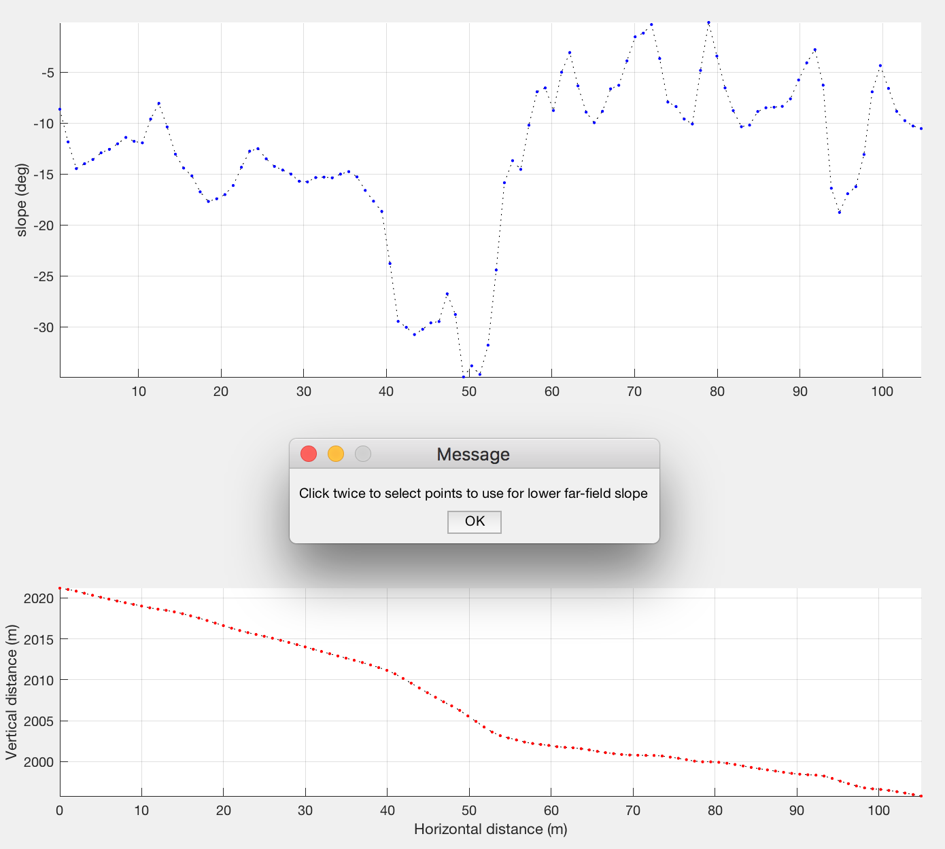
After clicking OK, line up the crosshairs in the lower panel and then click twice to define which points will to be used to determine the lower far-field slope. In the example below, I clicked at ~67 and ~104 m horizontal distance. Click OK for the message about selecting the lower far-field points, then repeat the procedure.

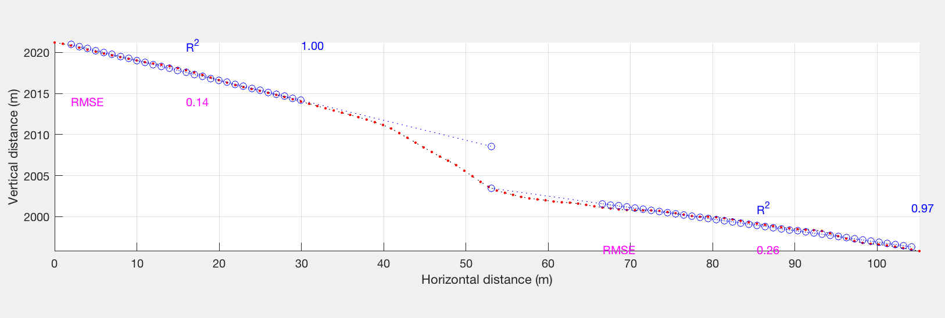
The figure should now show the upper and lower slopes in blue. Next, click OK for the message about selecting the scarp-slope points, then click twice on the steepest part of the scarp (use the slope-distance plot to guide your selection).

5. The program will then calculate an offset value and ask you if you want to "include" the results. Answering yes (1) means that you want to add the profile iteration to the total set. Saying no (0) will delete the offset value for that iteration (handy if you screw up a measurement).
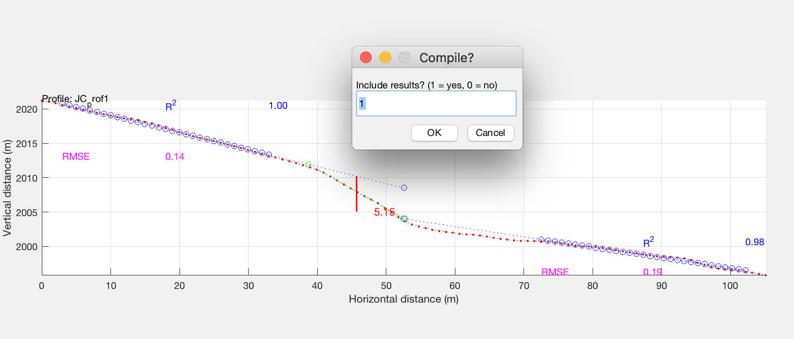

If you include the results, the program will keep track of the profile iteration number...1, 2, 3, etc. and write the results to the Matlab command window (and also save the results for writing to a file later). You can change the profile number if desired.
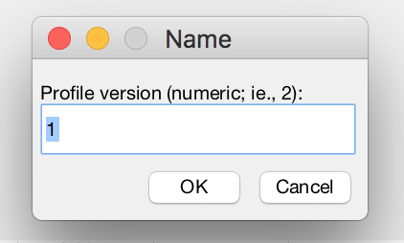
6. Preferred offset? After each iteration, you’ll be asked if the offset value just measured is the "preferred" value. If so, enter 1 in the dialog box.
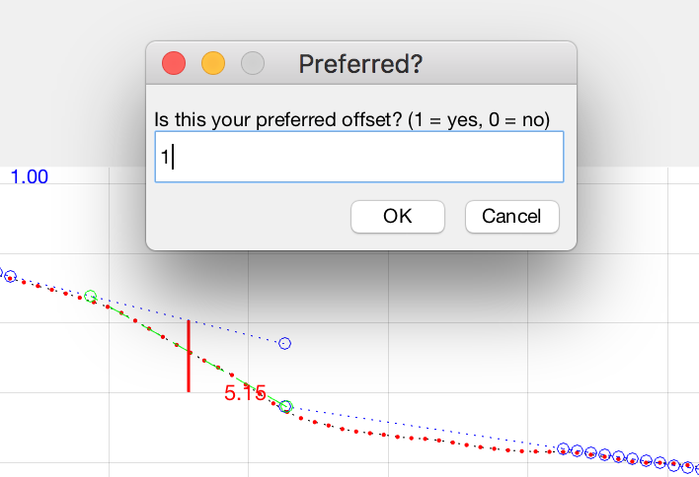
This offset measurement (5.15 m) is my preferred value. Important: only select one offset value to be the preferred value across all profile measurement iterations.
7. Begin a new measurement iteration?

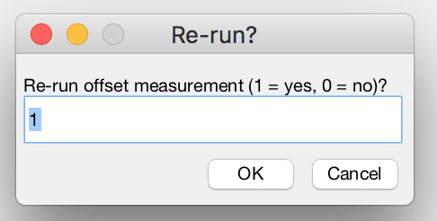
You’ve completed one measurement iteration. Your offset value is stored, but not yet saved. Before you save, you have the option to start over and measure an additional offset measurement. This is useful for attempting to determine the uncertainty in your offset values. For example, you could run several iterations using slightly different far-field slope measurements or aiming for a minimum or maximum values.

If yes (1), this will start a new offset-measurement iteration by returning to step 2.

Once you've completed as many measurement iterations as desired, enter 0 in the “re-run offset measurement” dialog box to move onto step 8.
8. Save? Next, you will be asked whether to save the results (all measurement iterations).
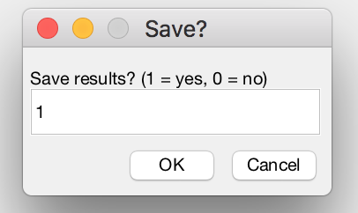

If you opt to save, you’ll have the option to add descriptive text to append to the file name (something like your initials that will be added to the original file name).
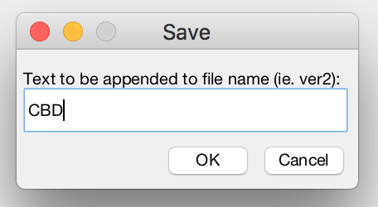

9. Preferred, mean or midpoint? Choose whether you want to report a preferred, mean, or midpoint offset value as a summary value. This value will be written in the "summary" file below.
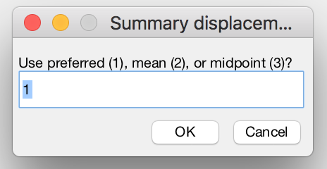
10. Files written. Lastly, the program will write four files to the directory:
A text file with the original name and "-summary" appended will have one column and the following rows:
- preferred/mean/midpoint vertical surface offset (depending on user selection)
- minimum vertical surface offset (from all profile iterations)
- maximum vertical surface offset (from all profile iterations)
- mean profile length (mean length using profile points selected in each iteration)
- mean lower far-field slope
- mean upper far-field slope
- mean scarp slope
- total number of profile iterations

A second text file will have "-individual" appended. There will be multiple columns (one for each profile iteration), with the rows consisting of:
- vertical surface offset
- profile length (same as above)
- lower far-field slope
4. upper far-field slope
5. scarp slope
- 6. whether profile is marked as "preferred" (1=yes, 0=no)

Finally, two Matlab files will be written to the directory. These will have the original file name (and descriptive text), as well as the appended text “_preferred_var.mat” and “_preferred.fig.”

The “var” file writes all of the Matlab variables (for the preferred offset) to a file; these can be opened in Matlab (e.g., to replot the figure).

The “fig” file is a Matlab figure file; opening this in Matlab will reproduce the offset measurement for the preferred offset.

